PROBLEM SOLVING TESTING USING JAVA

TASK 4 :- INTELLIGENT DNA PATTERN SEARCH USING(KMP)
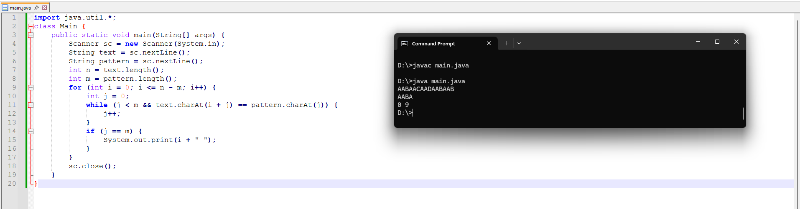

TASK 5 :- BANKING TRANSCATION SYATEM USING(OOP)
